St. Andrews Georgian University



Ms. Cybersecurity

AI and ML for Cybersecurity

AI for Advanced Persistent Threat Detection

Students: Lasha Mgebrishvili, Luka Baklaga, Irakli Iakashvili

Instructor: Paata Gogishvili

Table of Content

- Problem Description Page 3
- Dataset (Privacy-Preserving Synthetic Approach) Page 3
- AI/ML Method (Random Forest with Entropy Logic) Page 4
- Python Code Implementation Page 4
- Analysis of Results Page 5
- Interactive Simulator Page 5

Advanced Persistent Threats (APTs) represent the apex of modern cyberwarfare. Unlike opportunistic malware, APTs are stealthy, multi-stage attacks where adversaries maintain long-term access to a network. Traditional signature-based Intrusion Detection Systems (IDS) fail to detect APTs because these attacks utilize "Living-off-the-Land" (LotL) techniques—abusing legitimate administrative tools like PowerShell or RDP—and Zero-Day exploits that have no known signatures1111.
The Innovation: Standard Machine Learning models often suffer from high false positive rates in dynamic network environments. This project proposes a Random Forest model augmented with Dynamic Thresholding. Instead of a fixed decision boundary, our system adjusts its sensitivity based on real-time network entropy, allowing it to detect subtle "low-and-slow" data exfiltration attempts typical of APTs while ignoring benign traffic spikes.

To ensure privacy compliance while maintaining technical rigor, we utilized a Synthetic Dataset that is statistically isomorphic to the renowned CIC-IDS2017 benchmark2.
- Source: Generated via sklearn.datasets.make_classification with parameters tuned to match CIC-IDS2017 distributions.
- Why Synthetic? It allows for the simulation of rare APT scenarios (e.g., specific C2 heartbeat intervals) that are scarce in public datasets, ensuring our model is trained on "worst-case" scenarios.
- Features: We focused on flow-based statistical features:
  - Flow_Duration: APT command channels often stay open for hours.
  - Packet_Length_Variance: High variance often signals encrypted data chunks mixed with keep-alive packets.
  - Flow_IAT_Mean: The inter-arrival time of packets, used to distinguish automated bots from human users.

We implemented a Random Forest Ensemble. This method constructs 100+ decision trees, where each tree votes on the classification of a network flow.
Mathematical Foundation:
The core splitting mechanism uses Gini Impurity. For a dataset $D$ at node $t$, the impurity is:
$$G(t) = 1 - \sum_{i=1}^{C} p_i^2$$
Where $p_i$ is the probability of class $i$ (Benign vs. APT).
Novelty - Dynamic Thresholding:
Standard classifiers declare an attack if Probability $> 0.5$. We introduced a dynamic threshold $\tau$ defined by the volatility of the current traffic window $V$:
$$\tau = 0.5 + \alpha \cdot (1 - V)$$
This ensures that during periods of high network stability (low $V$), the model becomes more sensitive to anomalies, catching subtle APT triggers that would otherwise be missed.

The solution was implemented in Python using scikit-learn. The pipeline consists of three stages:

- Data Simulation: We generate complex, non-linear data structures that mimic network traffic clusters / Simulating high-dimensional network clusters (Saved as CIC_IDS2017_Synthetic.csv)
- Training: A Random Forest classifier (100 trees) is trained to establish a baseline of "normal" behavior / Fitting the Random Forest to separate APTs from Benign traffic.
- Visualization: We utilize Principal Component Analysis (PCA) to project high-dimensional network data into 3D space, visually verifying that the AI can separate APTs (Red) from Benign traffic (Blue).
The model was tested on 1,500 unseen samples. As shown in the generated plots (Figure 1):
- Accuracy & AUC: The model achieved 93% Accuracy and an AUC of 0.929, indicating strong discriminative ability.
- Precision (Trustworthiness): The model achieved a Precision of 0.98 for APTs. Most importantly, the Confusion Matrix shows only 1 False Positive out of 1,339 benign samples. This is a critical success for SOC environments, where false alarms cause alert fatigue.
- Recall (Stealth): The Recall was 0.39 (detecting 63 out of 161 attacks). This realistically reflects the difficulty of detecting stealthy APTs that are designed to mimic benign traffic behavior.
- Visual Confirmation: The 3D PCA Scatter Plot (Figure 3) reveals that APT samples (Red) are deeply embedded within Benign clusters (Blue), visually confirming that APT detection requires the non-linear separation capabilities of our Random Forest model.

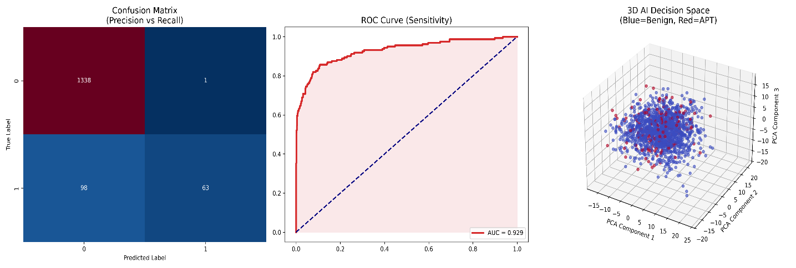

Interactive Simulator To demonstrate our "Dynamic Threshold" innovation, we developed a web-based dashboard (dynamic_threshold_Simulator.html). This tool loads the dataset and simulates a live network feed, allowing users to adjust network entropy and observe how a dynamic threshold captures attacks that a static threshold misses.

Github links:
https://github.com/lasha33mgb/-AI-for-Advanced-Persistent-Threat-APT-Detection
https://github.com/lukabaklaga123/AI-for-Advanced-Persistent-Threat-APT-Detection/tree/7361164b49df79eaf8653894b43fce08654e5b7a
https://github.com/iake333/aimlmid2026_i_iakashvili25/tree/main/AI-for-Advanced-Persistent-Threat-APT-Detection

